M2 Project: Presenting Data to Different Teams

I have considered my first business case as restaurant business. For this purpose, I have considered the dataset “Restaurant_revenue (1).csv”. Then I have prepared different reports to present.

**For your Data Science/Programming Team Head:**

* **Focus on technical details:**
  1. I have imported pandas, numpy and matplotlib.pyplot Python packages.
  2. Loaded the csv file.
  3. Checked if there are any missing values in the dataset
  4. Checked the column head
  5. Checked the first few rows
  6. Checked shape, values, columns and index of the dataset

# Import pandas with alias pd

# Import numpy with alias np

# Import matplotlib.pyplot as plt

import pandas as pd

import numpy as np

import matplotlib.pyplot as plt

# Use the csv dataset of Restaurant_revenue (1) and read in Python

rest_df = pd.read_csv(r"C:\Users\MR ASIS\Restaurant_revenue (1).csv")

# Check each column for missing values

print(rest_df.isna().any())

# Look at column heads of the dataset

print(rest_df.info())

# Look at first few rows of the dataset

print(rest_df.head())

# Look at other properties of the dataset

print(rest_df.shape)

print(rest_df.values)

print(rest_df.columns)

print(rest_df.index)

* **Present visually compelling results:**

Used different statistics as follows-

# Calculate basic statistics (mean, median, standard deviation, min, max, etc.) for each numerical columns

descriptive_stats = round(rest_df.describe(), 2)

print(descriptive_stats)

Used different tables-

# Group by Cuisine_Type and calculate Monthly_Revenue of each type

sales_by_type = round(rest_df.groupby("Cuisine_Type")["Monthly_Revenue"].sum(), 2)

print(sales_by_type)

# Creating lists

l1 = ["American", "Italian", "Japanese", "Mexican"]

l2 = [69018.84, 61178.37, 71185.45, 67341.52]

# Creating DataFrame

sales = pd.DataFrame(list(zip(l1, l2)))

sales.columns = ["Type of Cuisine", "Monthly Revenue"]

print(sales)

# Group by Cuisine_Type and calculate Number_of_Customers of each type

customers_by_type = round(rest_df.groupby("Cuisine_Type")["Number_of_Customers"].sum(), 2)

print(customers_by_type)

# Creating lists

l1 = ["American", "Italian", "Japanese", "Mexican"]

l3 = [13682, 12243, 14141, 13205]

# Creating DataFrame

customers = pd.DataFrame(list(zip(l1, l3)))

customers.columns = ["Type of Cuisine", "Number of Customers"]

print(customers)

# Get the propotion for each Cuisine Type

rest_df_props = round(sales_by_type / sum(sales_by_type), 2)

print(rest_df_props)

# Creating lists

l1 = ["American", "Italian", "Japanese", "Mexican"]

l4 = [0.26, 0.23, 0.26, 0.25]

# Creating DataFrame

proportion = pd.DataFrame(list(zip(l1, l4)))

proportion.columns = ["Type of Cuisine", "Proportion of Revenue"]

print(proportion)

# Pivot for mean Monthly_Revenue for each Cuisine Type

mean_sales_by_type = round(rest_df.pivot_table(values="Monthly_Revenue", index="Cuisine_Type"), 2)

print(mean_sales_by_type)

# Creating lists

l1 = ["American", "Italian", "Japanese", "Mexican"]

l5 = [269.60, 263.70, 271.70, 269.37]

# Creating DataFrame

avg_revenue = pd.DataFrame(list(zip(l1, l5)))

avg_revenue.columns = ["Type of Cuisine", "Average Monthly Revenue"]

print(avg_revenue)

Sorted the dataset ascending and descending order to see minimum and maximum value

# Sorting of Monthly_Revenue column

print(rest_df.sort_values("Monthly_Revenue"))

print(rest_df.sort_values("Monthly_Revenue", ascending=False))

As I found –ve revenue, I subset them

# Subsetting based on Monthly_Revenue

sub_month_revenue = round(rest_df[rest_df["Monthly_Revenue"] <= 0 ], 2)

print(sub_month_revenue)

Utilize charts, graphs, and dashboards to showcase trends, patterns, and key findings. Explain your visualizations clearly and emphasize meaningful takeaways.

* Utilized charts and graphs for **actionable recommendations.**

**For the CEO:**

* **Emphasize the business impact:**
  1. Our target is to raise revenue. Though some –ve revenue and many ups-downs, but mean revenue looks good which is 268.72.

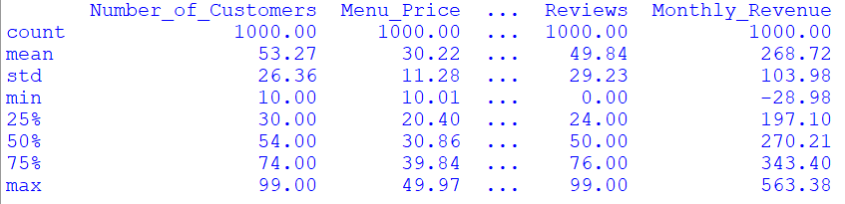

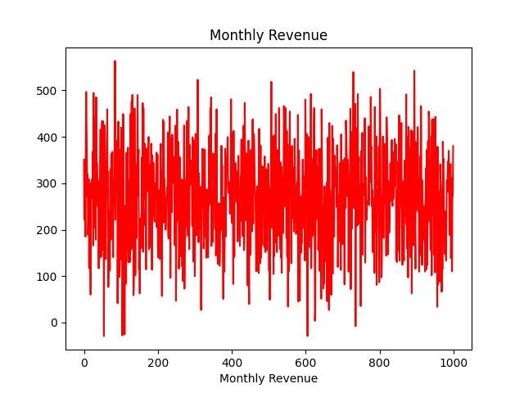

* 1. As we see from the graph that the number of customers and revenue are high positively correlated, we should more focus on customer satisfaction.

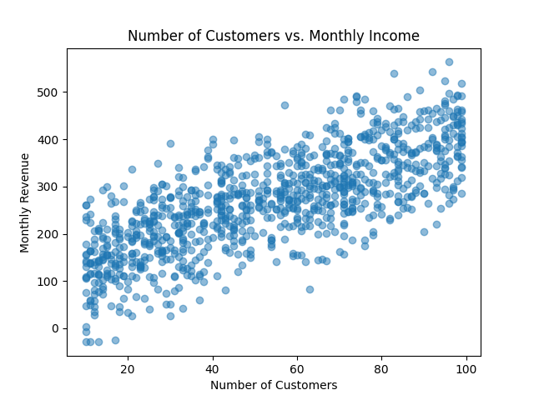

* **The compelling story:**

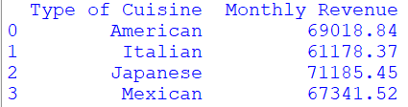

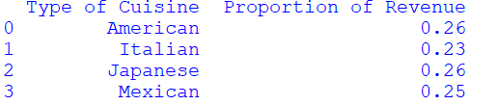

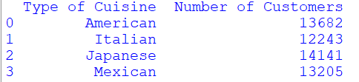

More customers like Japanese Cuisine, but proportion of American and Japanese are same.

There is no strong appeal regarding menu price.

